11/29/2025, Legacy (last week)

https://www.youtube.com/live/zrBbHGOHFU8?si=Ia0051qwh1wC74yC

“Come All Ye Hopeless | Come All Ye Faithless,” Dr. Jo Vitale

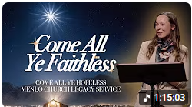

“Ye” = “y’all.” The phrase

1. "Come All Ye Hopeless" means “All of you who are without hope, come here".

2. "Come All Ye Faithless" means “All of you who are without faith, come here".

Introduction:

10:00/1:15:03

 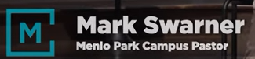

21:35/1:15:03

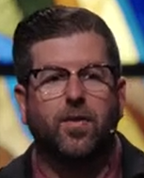 

Phil EuBank, Lead Pastor

 

Dr. Jo Vitale

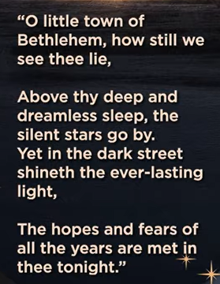

O little town of Bethlehem, how still we see thee (you) lie,

Above thy (your) deep and dreamless sleep, the silent stars go by. Yet in the dark street shineth (old word of “shines”) the ever-lasting light.

This is a beautiful and famous stanza (standing place) from the classic Christmas hymn (religious song), "O Little Town of Bethlehem," written by Phillips Brooks in 1867, describing how the divine "everlasting Light" (Jesus Christ) breaks the darkness of the world, fulfilling hopes and fears. It captures the quiet, sleepy nature of the town contrasted with the profound spiritual event happening within its "deep and dreamless sleep," with silent stars watching over.

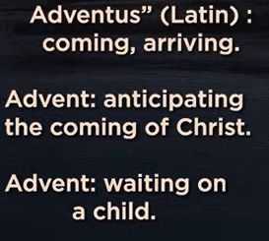

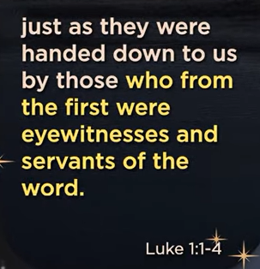 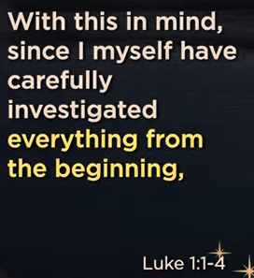

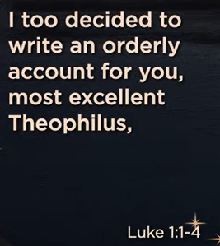 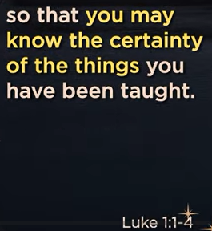

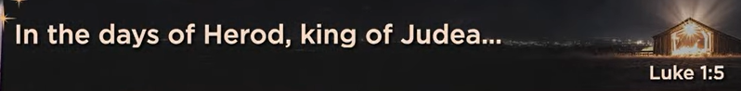

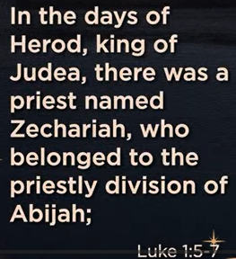 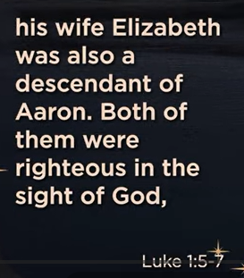 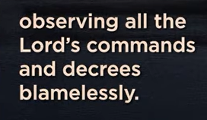 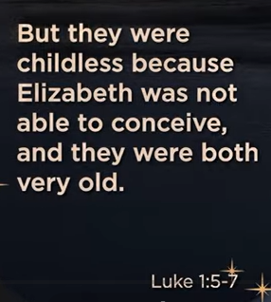

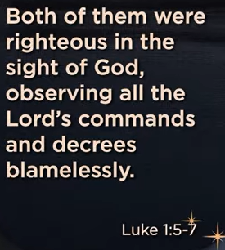

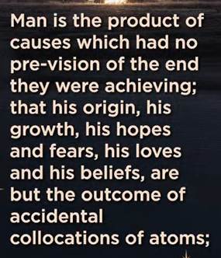 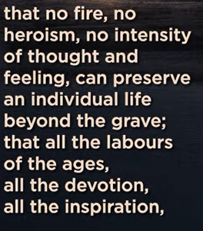

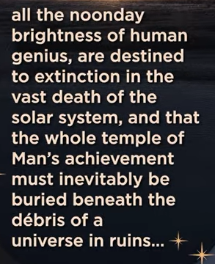 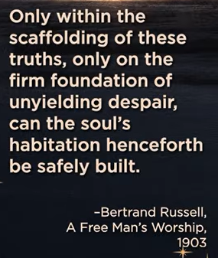

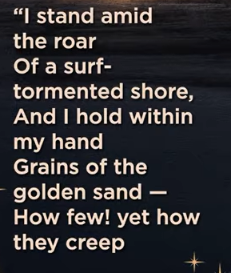 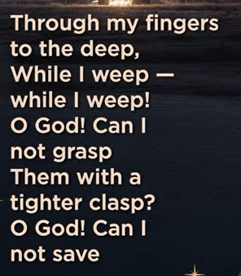 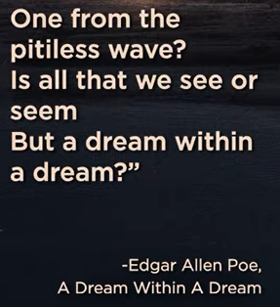

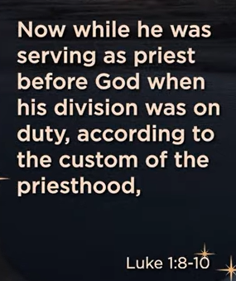 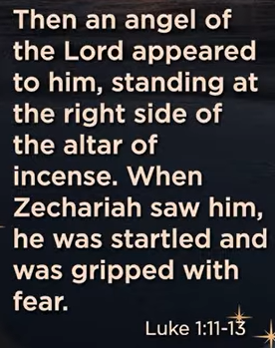 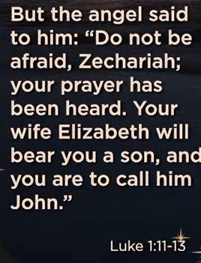

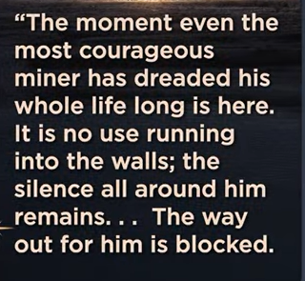 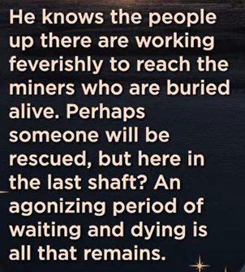

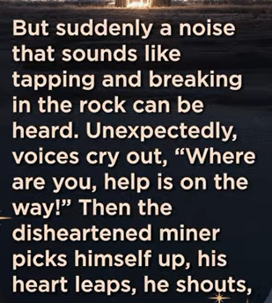 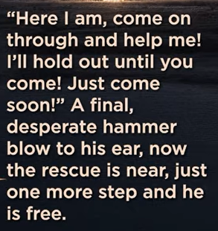

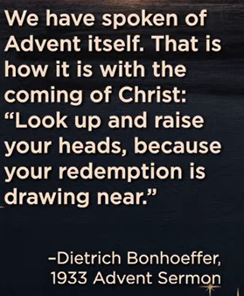

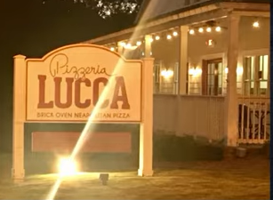

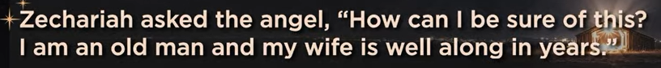

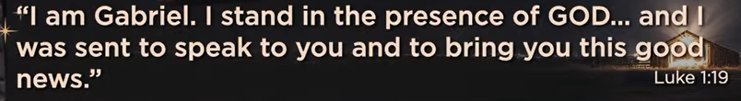

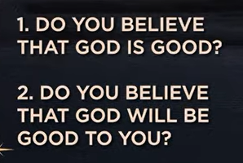

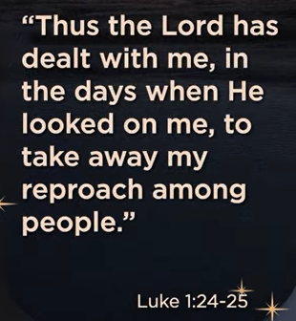

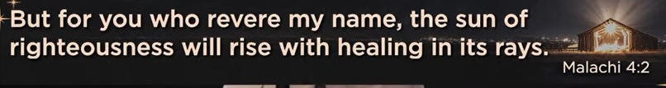

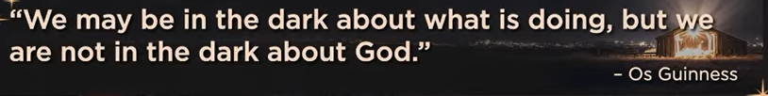

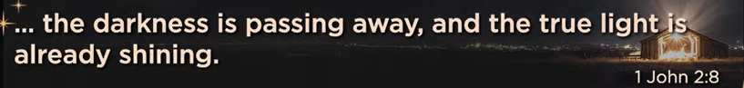

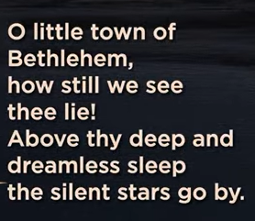 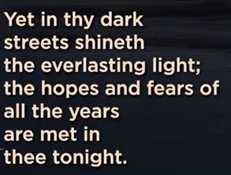

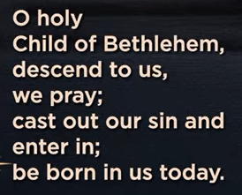 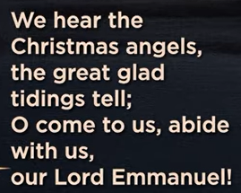

11/29/2025, Legacy (last week)

https://www.youtube.com/live/zrBbHGOHFU8?si=Ia0051qwh1wC74yC

“Come All Ye Hopeless | Come All Ye Faithless,” Phil EuBank, Lead Pastor

Summary: